Flask & MongoDB Assignment
DevOps Assignment — Tutedude

Submitted By: Umair Khan
Date: September 27, 2026
Course: DevOps Training — Tutedude
GitHub Repository: https://github.com/Umair-bey/Flask_and_MongoDB_UmairKhan

Table of Contents
- Objective
- Environment Setup
- Dependencies Installed
- MongoDB Atlas Setup
- Task 1 — JSON API Route
- Task 2 — Frontend Form with MongoDB Atlas
- Flask Request Logs
- Security Practices
- How to Run
- Conclusion

1. Objective
Build a Flask application with:
- A JSON API route (/api) that reads data from a backend file and returns it as a JSON list.
- A frontend HTML form that submits data to MongoDB Atlas:
  - On success: redirect to another page displaying "Data submitted successfully".
  - On error: display the error on the same page without redirection.

Technologies Used
Component | Version
Python | 3.14.2
Flask | 3.1.3
PyMongo | 4.18.1
dnspython | 2.8.0
python-dotenv | 1.2.3
MongoDB Atlas | Free M0 tier
Editor | VS Code
Shell | PowerShell / Command Prompt

2. Environment Setup

2.1 Python & pip Verification
Python 3.14.2 and pip 25.3 were already installed on the system. Verified with:
text
python --version
pip --version
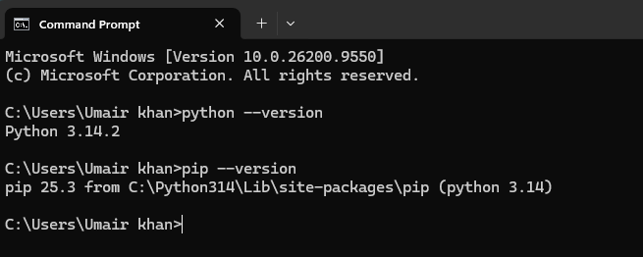
Figure 1: Python 3.14.2 and pip 25.3 verified

2.2 Project Folder & Virtual Environment
Created project folder Flask_and_MongoDB_UmairKhan on the Desktop, then created an isolated virtual environment to prevent dependency conflicts.
text
cd %USERPROFILE%\Desktop
mkdir Flask_and_MongoDB_UmairKhan
cd Flask_and_MongoDB_UmairKhan
python -m venv .venv
.venv\Scripts\activate
where python
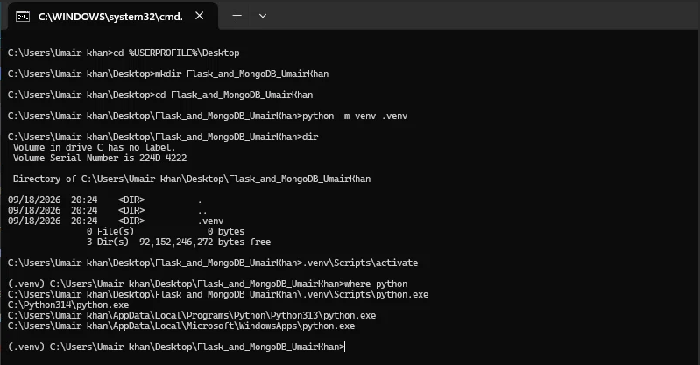
Figure 2: Virtual environment created and activated

2.3 Final Folder Structure
text
Flask_and_MongoDB_UmairKhan/
├── .env (MongoDB URI — gitignored)
├── .gitignore (excludes .env, .venv, __pycache__)
├── .venv/ (virtual environment)
├── app.py (Flask application)
├── requirements.txt (Python dependencies)
├── data/
│ └── data.json (backend file for Task 1)
├── screenshots/ (evidence for this doc)
├── static/ (reserved for assets)
└── templates/
├── index.html (form page)
└── success.html (success page)
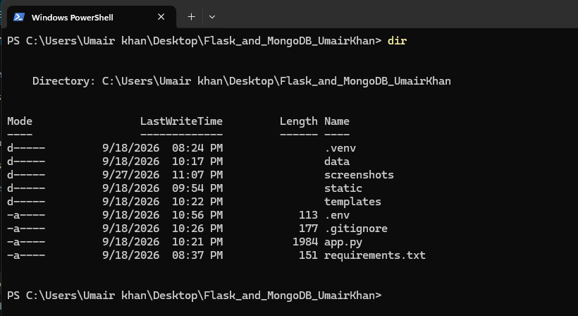
Figure 3: Required folders created via mkdir

3. Dependencies Installed
Installed via pip (inside the activated venv):
text
pip install flask pymongo dnspython python-dotenv
pip freeze > requirements.txt
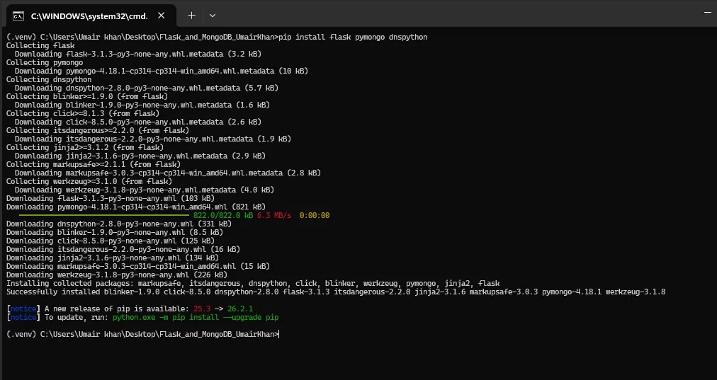
Figure 4: Flask, PyMongo, and dnspython installed successfully
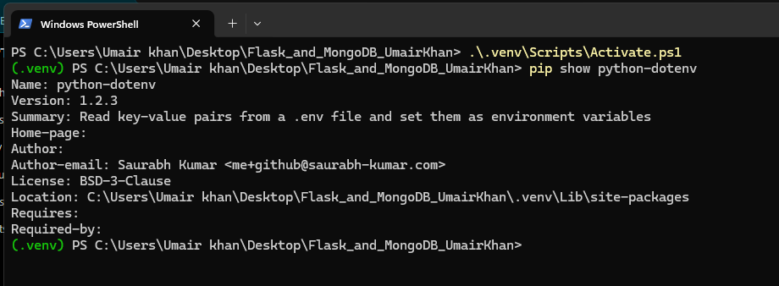
Figure 5: python-dotenv installed successfully

4. MongoDB Atlas Setup

4.1 Account & Free Cluster
- Created a free MongoDB Atlas account (Google Sign-In).
- Deployed a free M0 cluster on AWS, region Mumbai (ap-south-1).
- Cluster name: Cluster0.
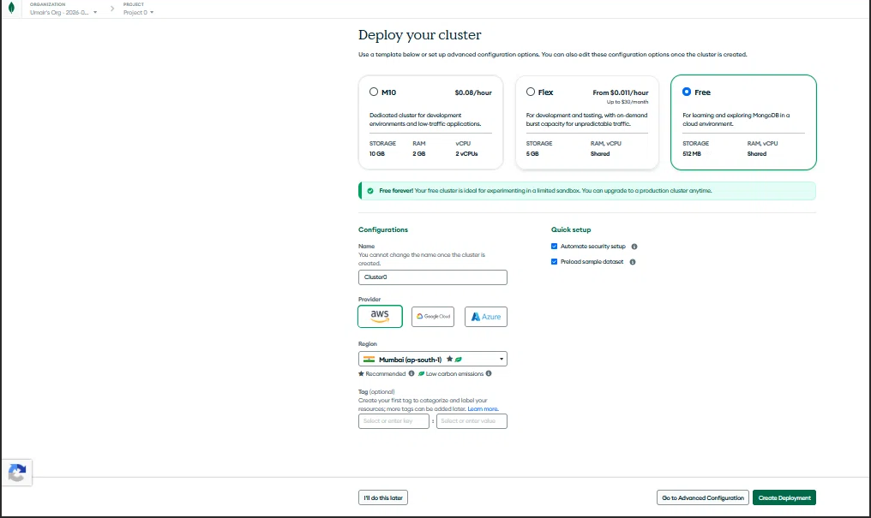
Figure 6: Free cluster configuration (Free tier, AWS, Mumbai)

4.2 Database User
Created a database user with read/write access: umair2025khanin_db_user.
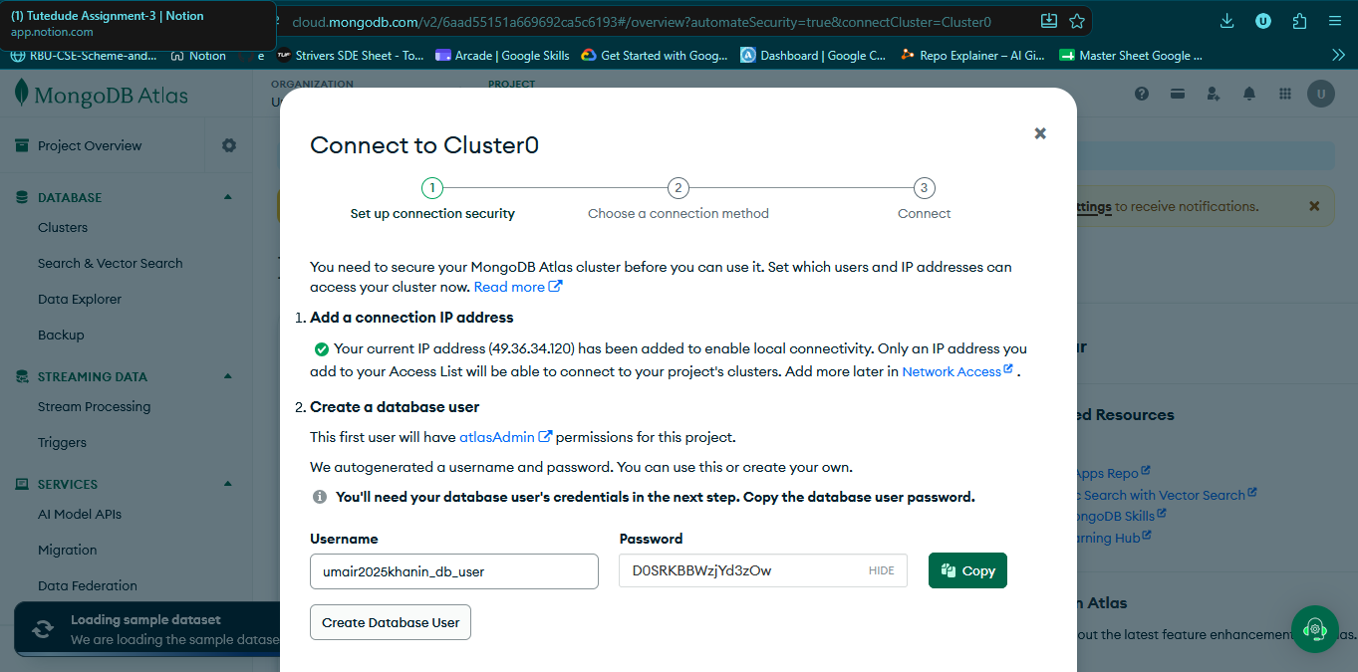
Figure 7: Database user credentials created

4.3 Network Access
Two IP rules were configured:
IP | Purpose | Status
49.36.34.120/32 | Current IP (auto-setup) | Active
0.0.0.0/0 | Allow from anywhere (development) | Active
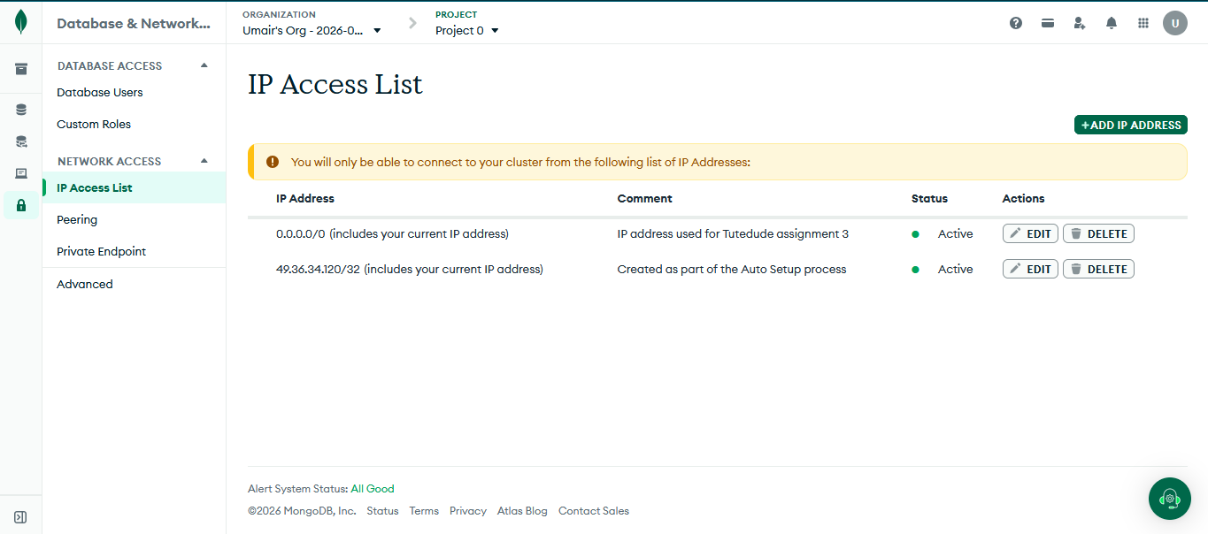
Figure 8: Network access whitelist

4.4 Connection String
Format:
text
mongodb+srv://umair2025khanin_db_user:<password>@cluster0.dvcs5w9.mongodb.net/?appName=Cluster0
Stored securely in a .env file (never committed to GitHub).
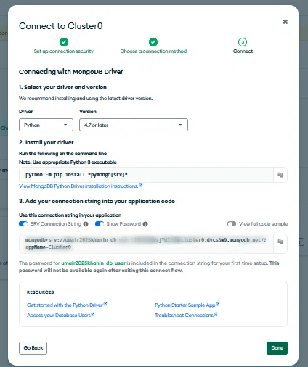
Figure 9: Connection string (password hidden)

4.5 Cluster Active
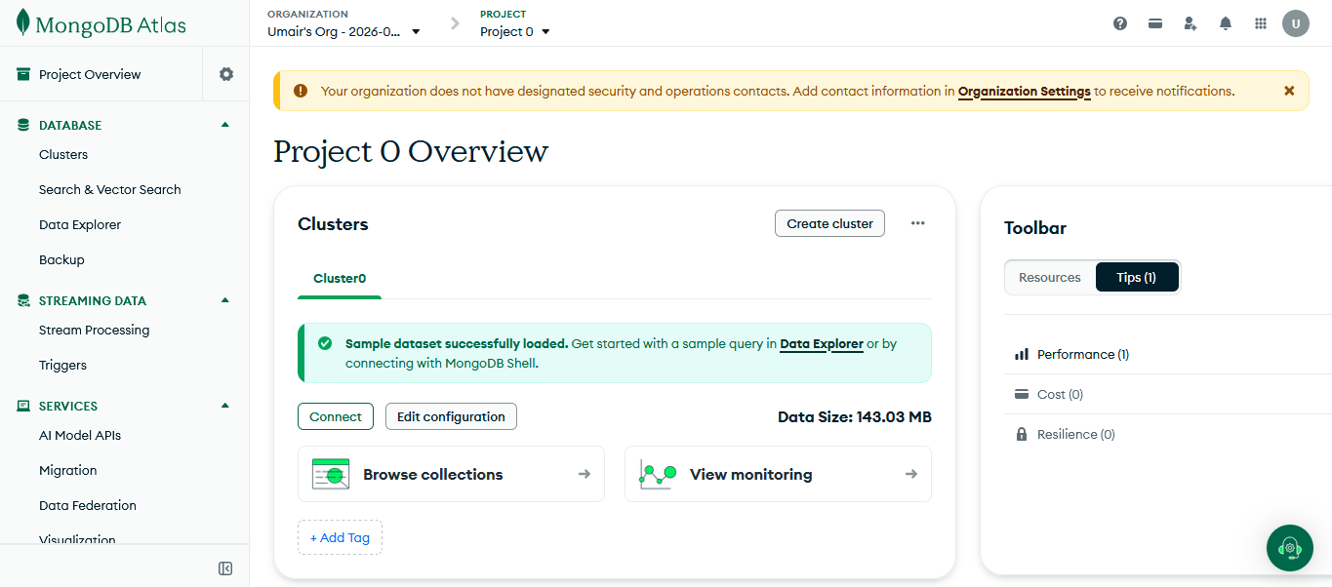
Figure 10: Atlas dashboard — Cluster0 active

5. Task 1 — JSON API Route

5.1 Requirement
Create a Flask application with an /api route that returns a JSON list. The data must be stored in a backend file, read from it, and returned as a response.

5.2 Backend File — data/data.json
json
[
{"id": 1, "name": "Priyanshu", "role": "DevOps Engineer"},
{"id": 2, "name": "Umair Khan", "role": "Tutedude Student"},
{"id": 3, "name": "Alice", "role": "Developer"},
{"id": 4, "name": "Bob", "role": "Designer"}
]

5.3 Implementation — app.py (Task 1 portion)
python
import os, json
from flask import Flask, jsonify

DATA_FILE = os.path.join(os.path.dirname(__file__), 'data', 'data.json')

def read_data_file():
with open(DATA_FILE, 'r') as f:
return json.load(f)

@app.route('/api', methods=['GET'])
def api():
data = read_data_file()
return jsonify(data)

5.4 Explanation
- The /api route only accepts GET requests.
- It reads data/data.json using Python's built-in json module.
- It returns the parsed data using Flask's jsonify(), which sets Content-Type: application/json.
- The route is stateless — each request reads the file fresh from disk.

5.5 Testing
Opened http://127.0.0.1:5000/api in the browser — the JSON array was displayed.
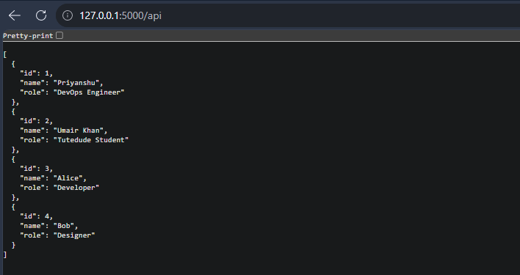
Figure 11: Task 1 — /api returns JSON list from backend file

6. Task 2 — Frontend Form with MongoDB Atlas

6.1 Requirements
- A frontend form that inserts submitted data into MongoDB Atlas.
- On success: redirect to another page displaying "Data submitted successfully".
- On error: display the error on the same page without redirecting.

6.2 Files Involved
- templates/index.html — form page
- templates/success.html — success page
- app.py — routes /, /submit, /success

6.3 Implementation — app.py (Task 2 portion)
python
from flask import render_template, request, redirect, url_for
from pymongo import MongoClient
from dotenv import load_dotenv

load_dotenv()
MONGO_URI = os.getenv("MONGO_URI")
client = MongoClient(MONGO_URI)
db = client.get_database('tutedude_db')
collection = db['submissions']

@app.route('/')
def index():
return render_template('index.html')

@app.route('/submit', methods=['POST'])
def submit():
try:
data = request.form.to_dict()
if not data.get('name') or not data.get('email'):
raise ValueError("Name and Email are required.")
collection.insert_one(data)
return redirect(url_for('success'))
except Exception as e:
return render_template('index.html', error=str(e))

@app.route('/success')
def success():
return render_template('success.html')

6.4 Explanation
- The / route renders the form.
- The form posts to /submit with method="POST".
- On /submit:
  - Form data is extracted via request.form.to_dict().
  - Input is validated (name and email required).
  - On success: record is inserted via collection.insert_one(), then Flask issues a 302 redirect to /success.
  - On error: the same form page is re-rendered with the error message — no redirect.

6.5 Success Case — Test
Submitted the form at http://127.0.0.1:5000/. Browser redirected to /success.
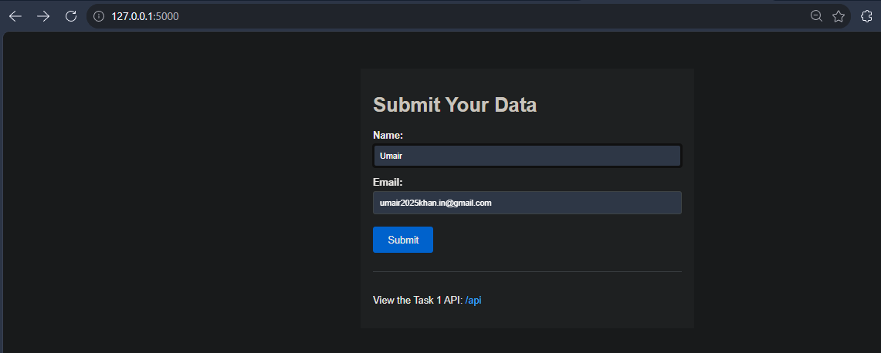
Figure 12: Task 2 — form page
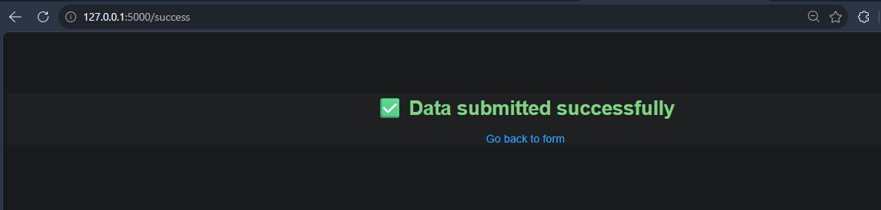
Figure 13: Task 2 — success page after valid submission

6.6 Error Case — Test
Temporarily replaced the password in .env with an invalid value, restarted Flask, and submitted the form. The browser showed a red error box on the same page (no redirect).
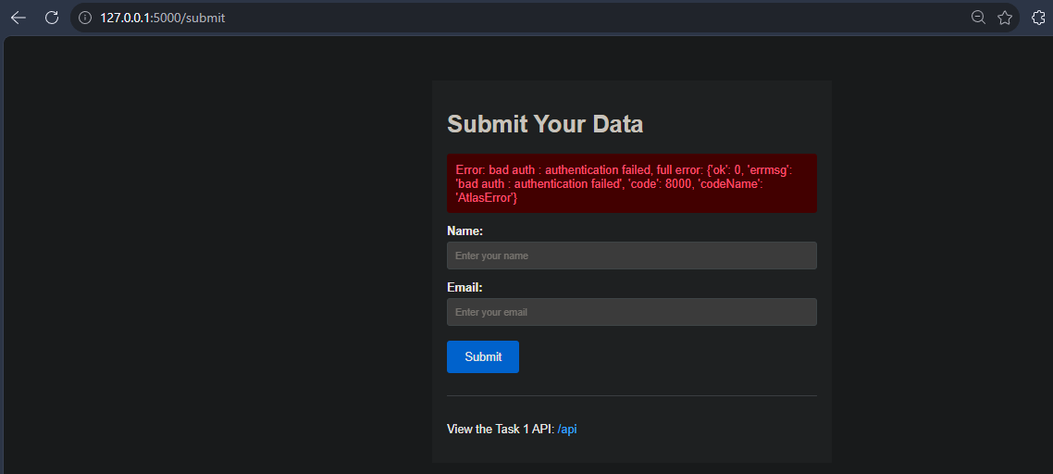
Figure 14: Task 2 — error displayed on same page (URL stays on /submit)

6.7 Data Verified in MongoDB Atlas
Opened MongoDB Atlas → Data Explorer → tutedude_db → submissions. Documents from the form submission were visible.
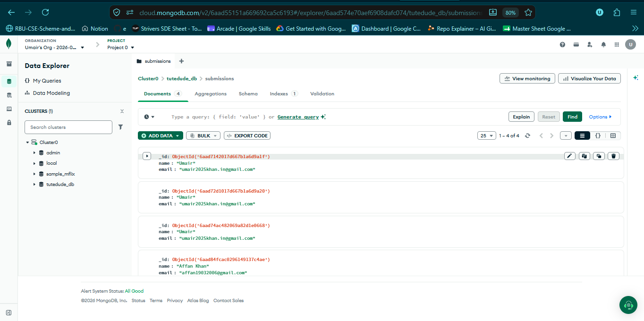
Figure 15: Documents inserted into MongoDB Atlas

7. Flask Request Logs
The Flask terminal captured the full request sequence during testing:
text
127.0.0.1 - - [...] "GET / HTTP/1.1" 200 -
127.0.0.1 - - [...] "POST /submit HTTP/1.1" 302 - ← Redirect fired
127.0.0.1 - - [...] "GET /success HTTP/1.1" 200 -
127.0.0.1 - - [...] "GET /api HTTP/1.1" 200 -
Line | Status | Meaning
GET / 200 | OK | Form page loaded
POST /submit 302 | Redirect | Task 2 success case — redirect issued
GET /success 200 | OK | Success page loaded
GET /api 200 | OK | Task 1 — API returned JSON
The 302 status code on POST /submit is direct evidence that the redirect requirement for Task 2 was satisfied.
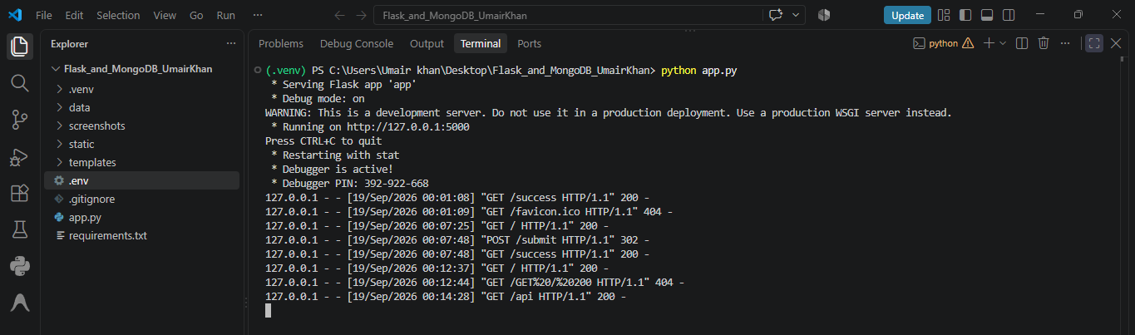
Figure 16: Flask request logs — POST /submit returns 302

8. Security Practices
- Environment variables: The MongoDB connection string is stored in a .env file (loaded via python-dotenv), not hardcoded in app.py.
- .gitignore: Excludes .env, .venv/, and __pycache__/ from Git, so secrets and machine-specific files are never committed.
- Password rotation: The database user password was rotated via MongoDB Atlas → Database Access during development, minimizing risk from any exposure.
.gitignore contents:
text
# Environment variables (secrets)
.env

# Virtual environment
.venv/
venv/

# Python cache
__pycache__/
*.pyc

# VS Code
.vscode/

# OS files
.DS_Store
Thumbs.db
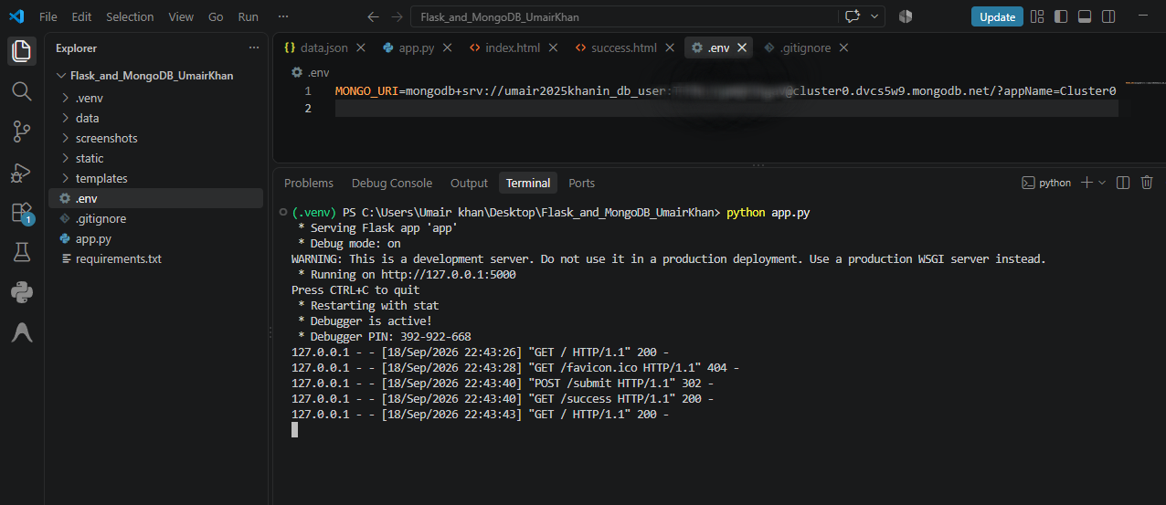
Figure 17: .env file containing MONGO_URI (sensitive — blurred in submission)

9. How to Run
Prerequisites: Python 3.10+, MongoDB Atlas account (free tier).
Steps:
Clone the repository:
text
git clone https://github.com/Umair-bey/Flask_and_MongoDB_UmairKhan.git
- cd Flask_and_MongoDB_UmairKhan
Create and activate a virtual environment:
text
python -m venv .venv
- .venv\Scripts\activate
- Install dependencies:
text
pip install -r requirements.txt
- Create a .env file with your own MongoDB URI:
text
MONGO_URI=mongodb+srv://<user>:<pass>@<cluster>.mongodb.net/?appName=Cluster0
- Run the app:
text
python app.py
- Open in browser:
  - http://127.0.0.1:5000/ — form page (Task 2)
  - http://127.0.0.1:5000/api — JSON API (Task 1)

10. Conclusion
Both tasks were successfully implemented, tested, and documented:
- Task 1 — The /api route returns a JSON list read from data/data.json.
- Task 2 — The frontend form inserts data into MongoDB Atlas, redirects to a success page on success (HTTP 302), and displays errors on the same page without redirecting (proved via forced authentication failure).
The project follows best-practice structure (virtual environment, environment variables, .gitignore), and all functionality is verified with terminal logs and browser screenshots.
GitHub Repository: https://github.com/Umair-bey/Flask_and_MongoDB_UmairKhan

✅ Done — How to Finish
- Copy the entire content above (from # Flask & MongoDB Assignment down to the GitHub link at the end).
- Paste into Google Docs (Blank document).
- Rename the doc: "Flask & MongoDB Assignment - Umair Khan"
- Insert screenshots at each **[Insert Screenshot Here]** marker — 17 images total.
- File → Download → Microsoft Word (.docx) — also download as PDF.
- Move both files into C:\Users\Umair khan\Desktop\Flask_and_MongoDB_UmairKhan\
- Rename to Documentation.docx and Documentation.pdf.
Then we move to GitHub push. 🚀

